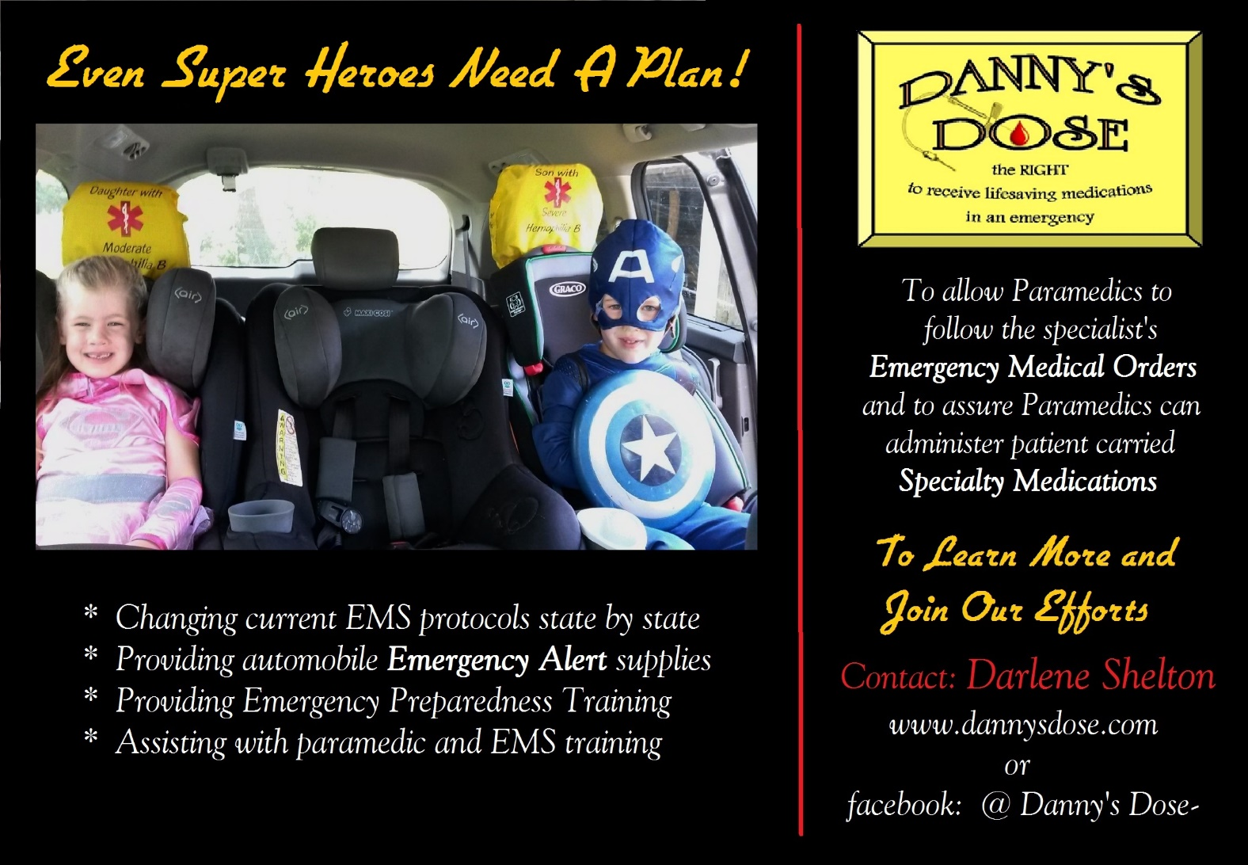

DANNY’S DOSE – The Campaign to Change the Emergency Medication Protocols!

How much more that means to our family two years later! How much we have learned about the true need to educate not only our legislators and EMS personnel; but also, our own bleeding disorders families to “HAVE A PLAN” and make preparation.

What can or should you do right now, you may ask?
For Your Protection To Raise Awareness
- Have an Emergency Dose Kit always with you * Join us – email me your contact info to be
- Ask your local EMS Service for a “treatment plan” added to your state group
- Ask your local ER for a “treatment plan” * Help us with phone calls and emails
Education for both EMS and ER is available We even have scripts available
- Get an Emergency Medical Orders letter from * Call your Rep and Senator so they are aware
your specialist & have copies with you! of the issue. (We can help with that also.)
- Mark your auto with Emergency Alert items * Help contact other rare disease groups who
- Always wear a Medical Alert bracelet or necklace may be affected

We have learned that our current EMS regulations actually have conflicting protocols and some gaps in liability protection for the advisory physicians and paramedics. This is what puts us in danger of not being treated in an emergency but this can be changed!

By standing up in our home state of Missouri, we currently have legislation in the House and the Senate which addresses these issues. EMS education for rare diseases and specialty meds has started, plans for standardization of Emergency Medical Orders are in progress and template protocols are being drafted to go with the legislation!

We are joining with several other rare disease groups! We can do this across the U.S. We need each of you to join with us so each state has a LOUD voice to insure the changes are made for the protection of each of our SUPER HEROES!

